CSP584 – Hotel Reservation

Software Requirement Specifications

Fall 2017

**Team 6:**

* **Jinyang Li - A20317851 –** <jli134@hawk.iit.edu>
* **Tai Nguyen – A20356881 –** [tnguye52@hawk.iit.edu](mailto:tnguye52@hawk.iit.edu)
* **Sreeharsha Pachipala - A20359998 -** [spachipa@hawk.iit.edu](mailto:spachipa@hawk.iit.edu)
* **Vikas Prathap - A20352158 -** [vprathap@hawk.iit.edu](mailto:vprathap@hawk.iit.edu)

Contents

Overview 3

Requirement 4

Database Specifications 5

Class Diagram 6

# Overview

A hotel management system that allows customer to make room reservation orders in hotels.

This system provides access for managers and staffs to manage the hotels, hotel rooms and customer orders. Data analytics are also available for managers.

The system can perform hotel-wide discount on deal matches.



Customer

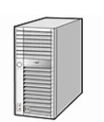

Hotel System



Staff



**5. Room reservation**

**2. Manage hotel**

**3. Manage room**

**4. Manage order**

**8. Write Review**

**9. Cancel Order**

**10. Data Analytics**

**7. Check-out**

**6. Check-in (assign room)**

**1. Deal Parsing**

Manager

External APIs

# Requirement

* Deal Parsing:
  + Read from ./resources/DealMatches.txt. (sample deals only, no API GET available)
  + Parse the read deals, apply the above discounts hotel-wide.
* Manage hotel:
  + Manager can add/update/delete hotels.
  + Hotel: name, address, description, images.
* Manage room:
  + Consists of Room Type and Room numbers.
  + Room Type: Name and features of a room type.
  + Room numbers: Managed by a list in Room Type.
  + Manager can add/update/delete Room Types.
* Manage order:
  + Staff and Manager can add/update/delete customer orders.
* Create account:
  + Manager can create Manager/Staff/Customer accounts.
  + Customer can create Customer accounts.
* Room reservation:
  + Customer can reserve a room from a hotel.
  + Workflow:
    - Customer searches for hotel in an area.
    - When found, Customer chooses a Room Type available.
    - Reservation requires Customer to be signed in.
    - Customer places order.
* Check-in:
  + Staff and Manager can check-in room for reserved customers.
  + Can only do orders that are checked-in for the current date.
  + Customer will be assigned a room number, given the ordered room type.
* Check-out:
  + Staff and Manager can check-out room for checked in customers.
  + When checked-out, order check-out time will be updated accordingly.
  + Occupied room number will be available again.
* Write Review:
  + Customer can write Review for their own booked order.
* Cancel Order:
  + Customer can cancel Placed orders.
* Data Analytics:
  + Trending functions are available for Manager.
  + Hotel Report and Sales Report are available for Manager.

# Database Specifications

* Uses MySQL as main database, MongoDB for review storage.
* On app startup, automatically import MySQL script from ./resources/sql/setup.sql.
* Schema diagram:

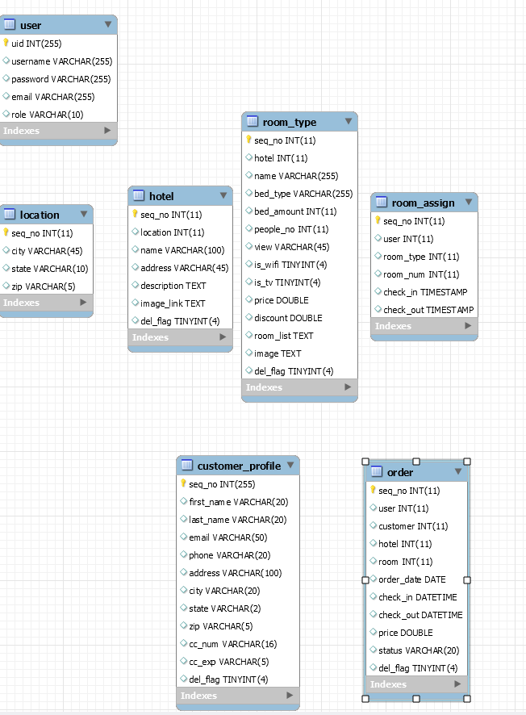

# Class Diagram

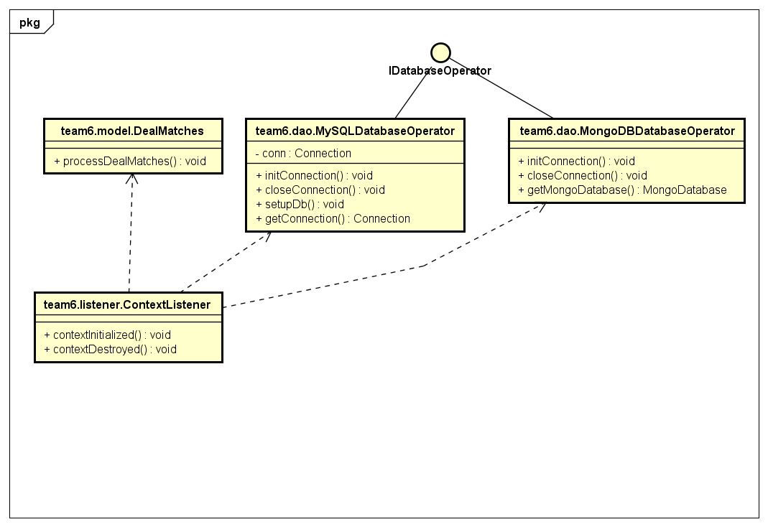

Diagram 1: On web app startup.

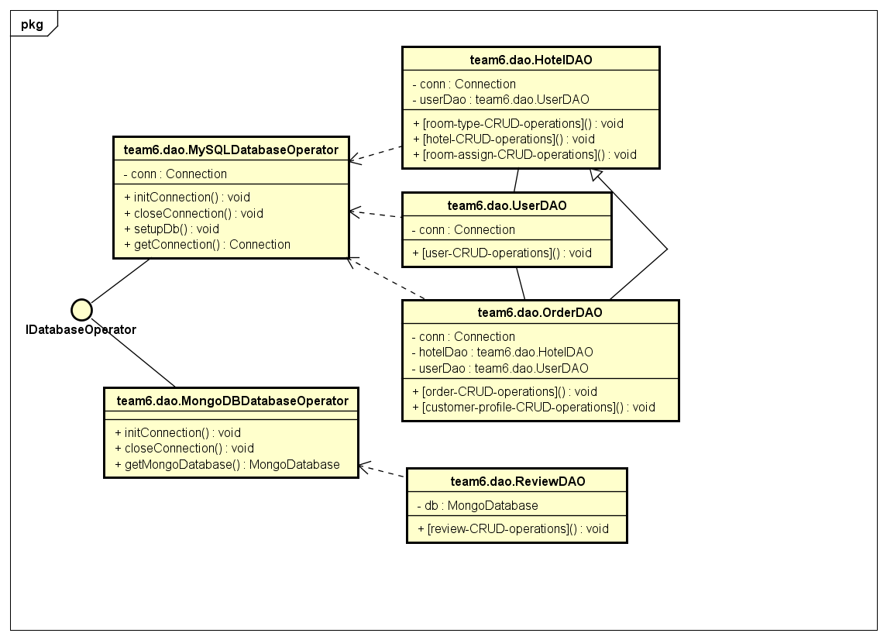

Diagram 2: Class diagram of DAOs

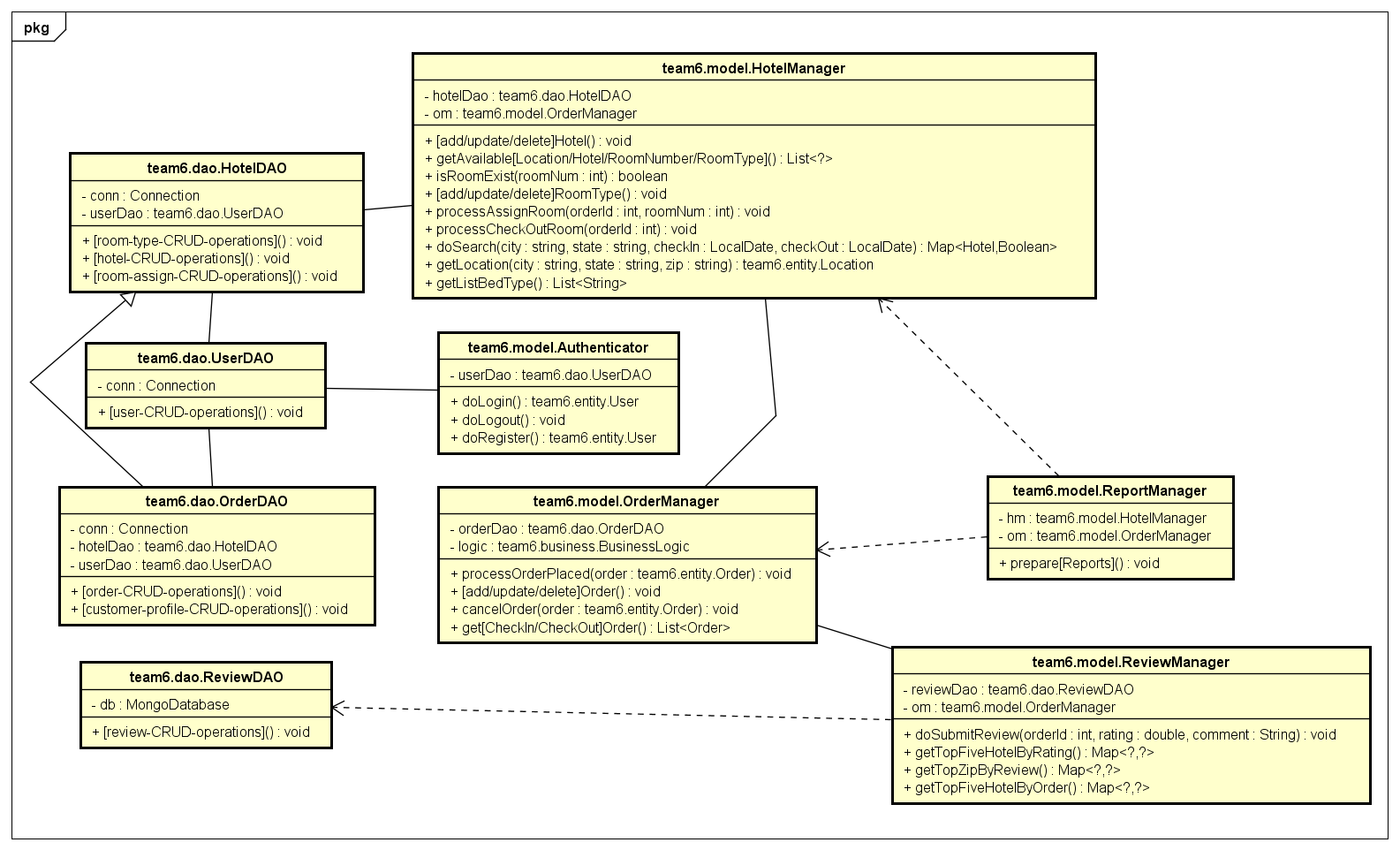

Diagram 3: Class diagram of DAO-Model Relations.

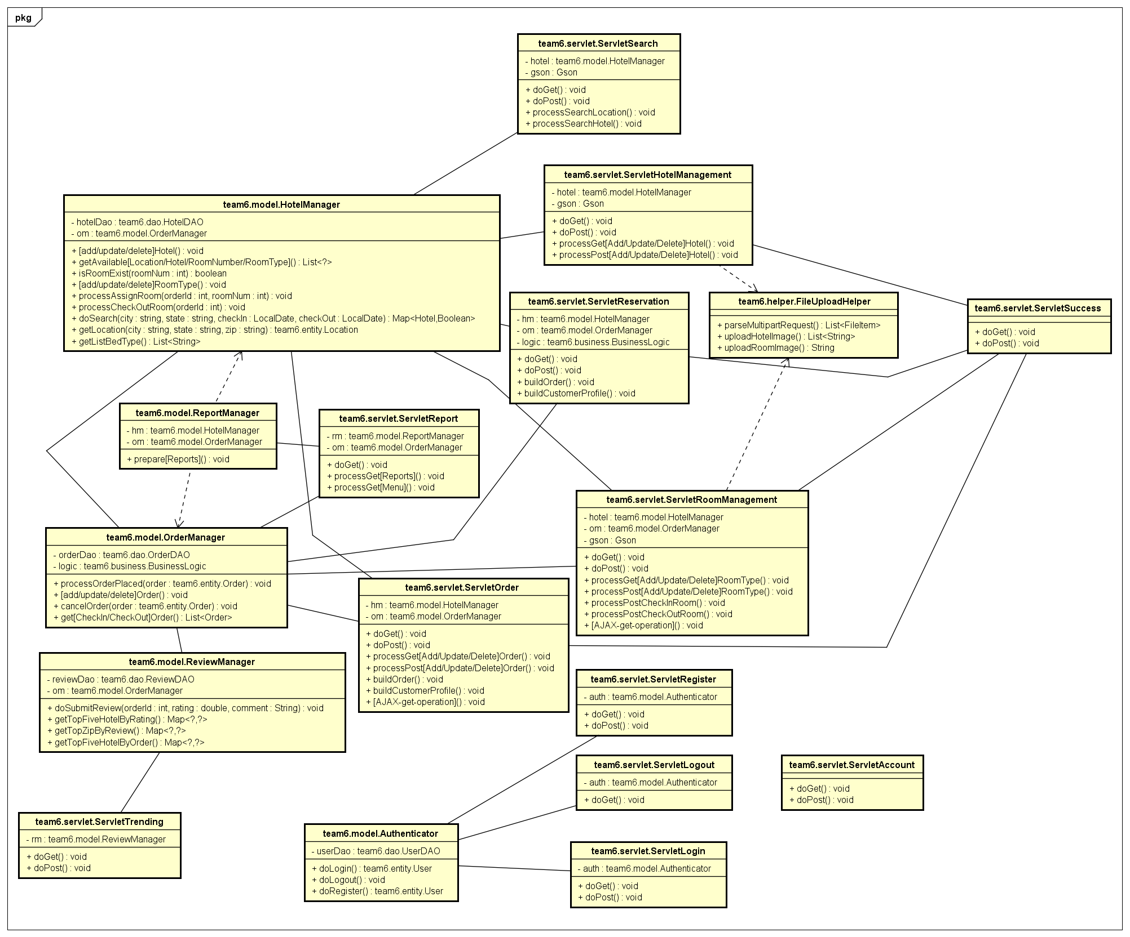

Diagram 4: Class diagram of Model-Servlets relations